select ename , job,deptno from emp where job='CLERK';

select ename , job,deptno from emp where job='MANAGER';

select ename , sal , comm from emp where sal<=1200;

select ename , sal , comm from emp where sal between 1000 and 1500;

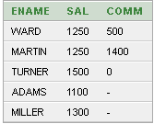

select empno ,ename , sal , sal , mgr from emp where mgr in (7902 , 7566,7788);

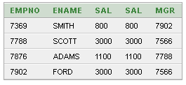

select ename from emp where ename like '%A%';

select ename ,mgr from emp where mgr is null;

select ename , sal ,job from emp where sal>=1200 or job ='CLERK';

select ename , sal ,job from emp where sal>=1200 and job ='CLERK';

select ename , sal ,job from emp where job not in ('CLERK');

select ename , sal ,job from emp where job ='CLERK' or job='ANALYST' and sal>=1200 ;

select * from emp order by sal;

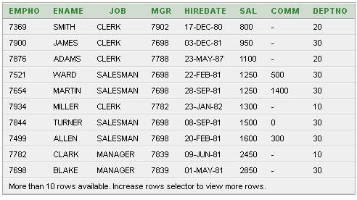

select * from emp order by sal desc;

select ename , sal , sal*12 "Annual" from emp order by "Annual";

select empno , ename , deptno from emp where lower(ename)='king';

select ename, concat(ename,job) ,length(ename), instr(ename,'A')

from emp ;

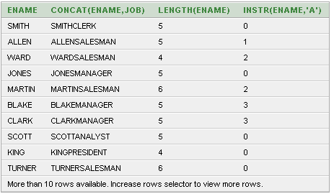

select round(45.923,2),round(45.923,0),round(45.923,-1) from dual;

select empno ,ename , sal , mod(empno , sal) from emp;

select ename , to_char (hiredate , 'fmDD Month YYYY') HIREDATE from emp;

select ename , sal , comm , (sal*12)+nvl (comm,0) from emp;

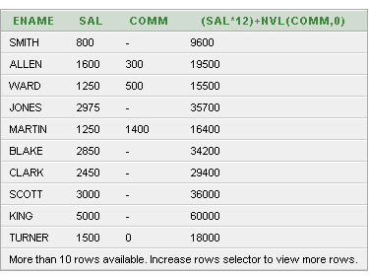

select avg(sal), max(sal), min(sal), sum(sal) from emp where job like 'SALES%';

select min(hiredate), max(hiredate) from emp;

select count(*) from emp where deptno = 30;

select count (comm) from emp where deptno = 30;

select avg (comm) from emp;

select avg (nvl (comm, 0)) from emp;

select deptno, avg(sal) from emp group by deptno;

select avg(sal) from emp group by deptno;

select deptno, max(sal) from emp group by deptno having max(sal) > 2900;

select job, sum(sal) PAYROLL from emp where job not like 'SALES%' group by job having sum(sal) > 5000 order by sum (sal);

select max(avg(sal)) from emp group by deptno;

